2.8 Citizen-Community Science
Maryland Department of Environment – Participant in “Rethink Recycling” | November 2022  November 2021  November  2019  November 2018  November 2017 | America Recycles Day (ARD) is a national event (November 15th) that promotes recycling, source reduction and buying products made from recycled materials as objectives to a more sustainable society. In celebration of ARD, MDE has created the “Rethink Recycling” sculpture contest and judging ceremony to display students’ creativity and promote recycling. The sculpture contest and judging ceremony is a great opportunity for celebrating efforts of the student artists, for media exposure and for promoting waste prevention to the general public. The sculpture contest challenges students to innovatively and artistically use recycled materials as a solution to waste reduction. If you would like more information about ARD, visit the America Recycles Day's web page.
Community | Met with David Riley- Six Bridges Community Greenway Taskforce Chairperson  David Marks (Baltimore County) to review future plans for our local watershed and presented researched solutions | Action: students created action plans and submitted to local government with solutions for the excessive flooding from Towson Run and Herring Run. | See attachments for student samples of plans  Below are images of students from social media.
Trader Joe’s Earth Day | April 2022 | Students went to our local Trader Joe’s and had paper bags donated to THS for students to decorate for Earth Day. Students in Earth Systems classes decorated Earth Day bags. The bags were returned to Trader Joe’s to give to local members of the community as they purchased their groceries. | 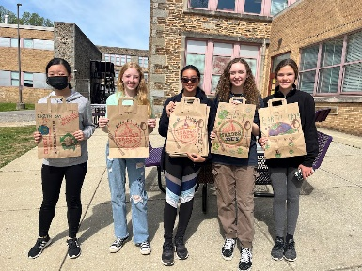
Postcards to the governor | January 2023 | Students wrote postcards to the governor and hand delivered them to encourage Governor Moore to sign off on providing funding to schools for composting.

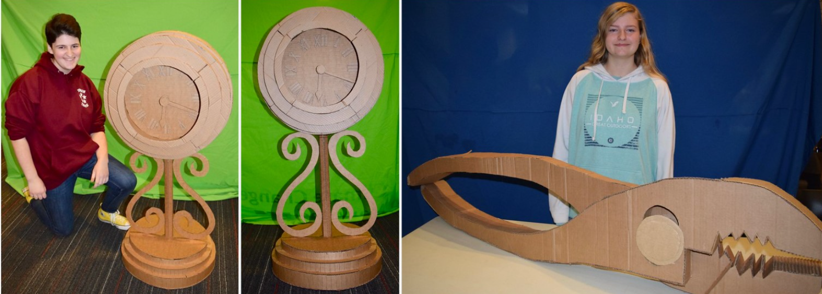
RETHINK RECYCLING
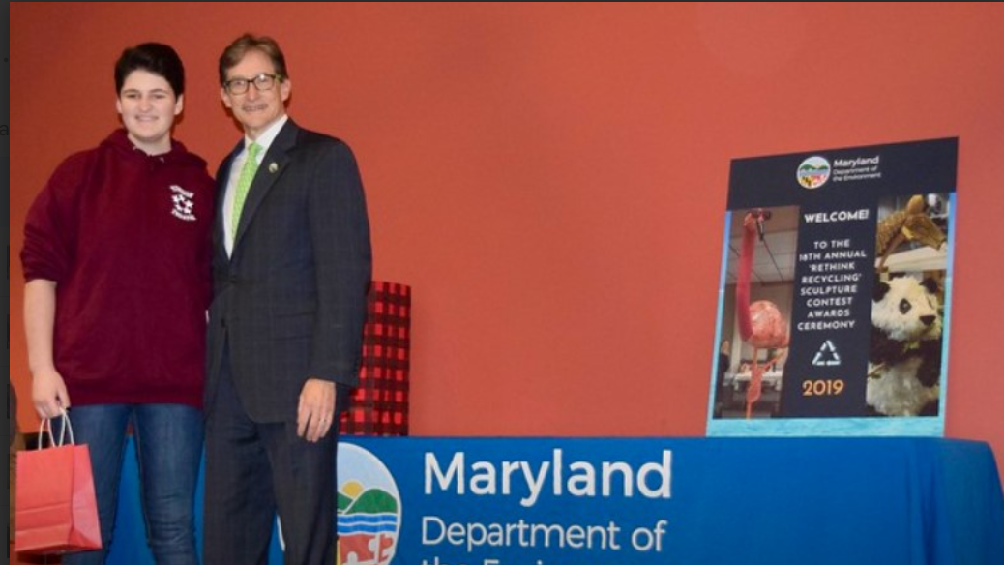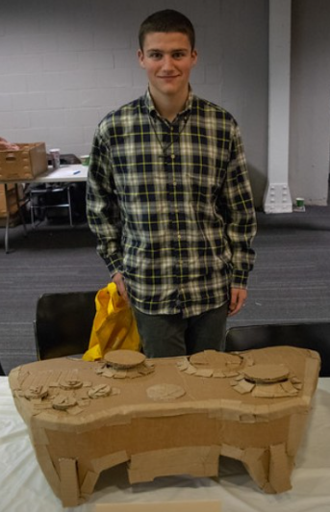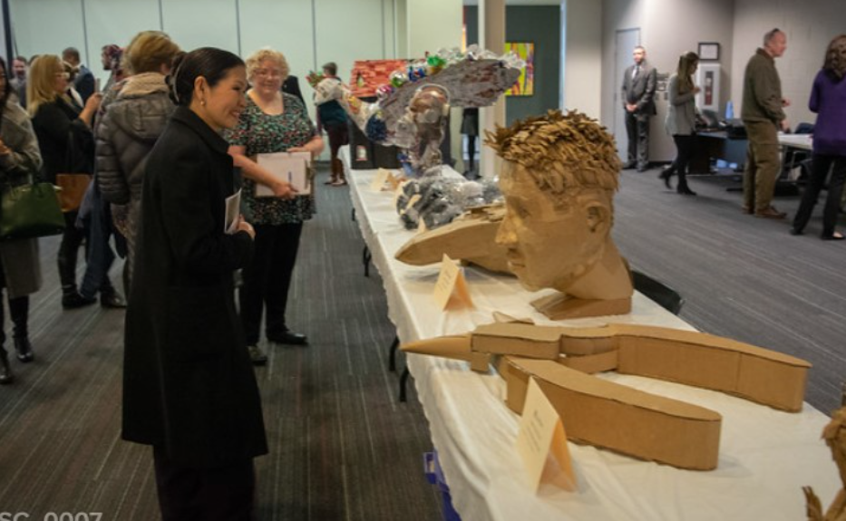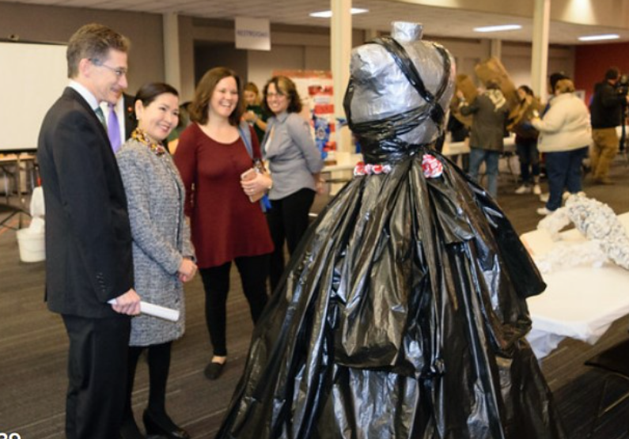

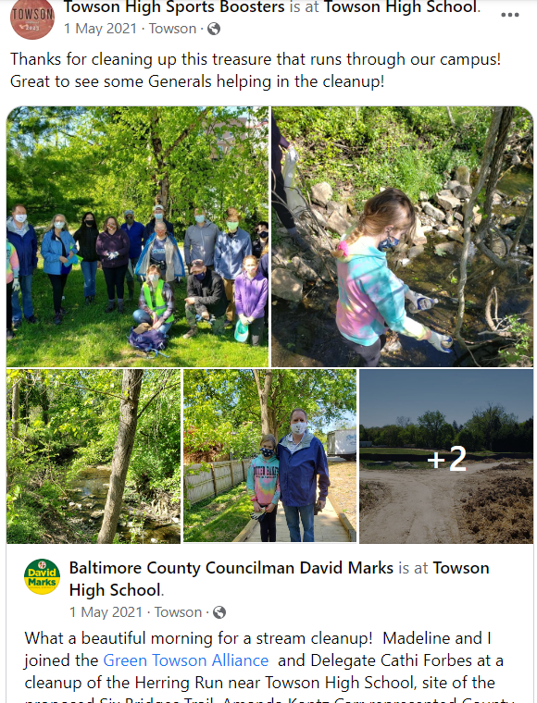
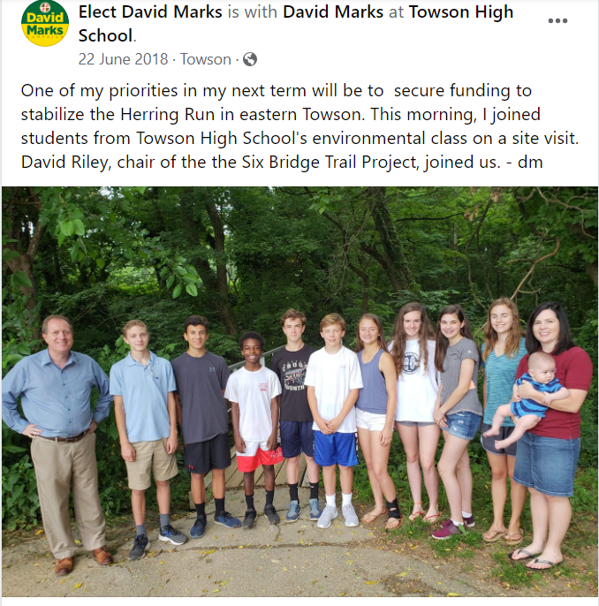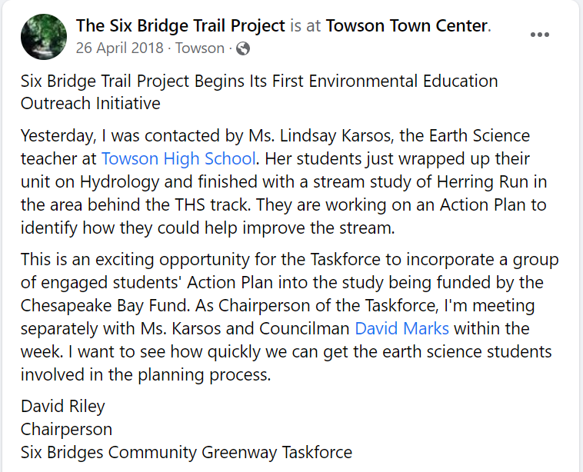
Action Projects
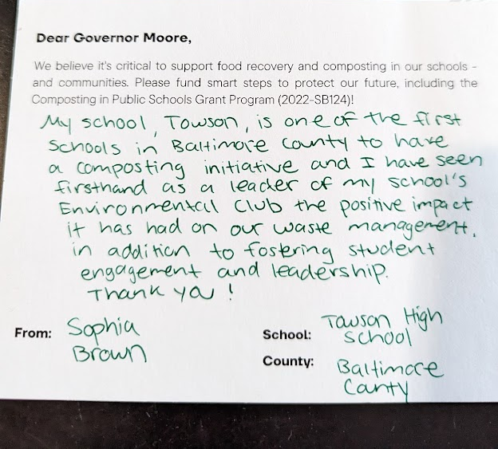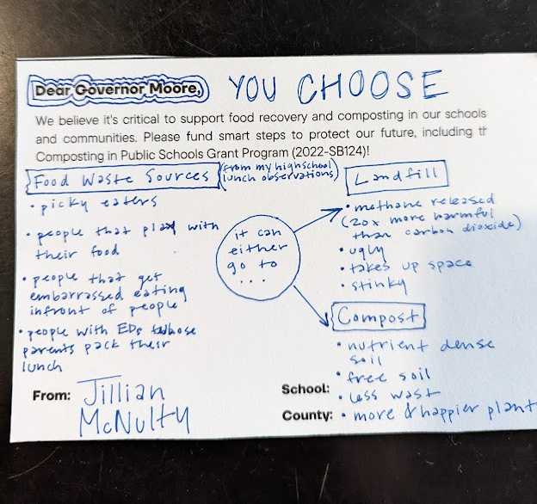
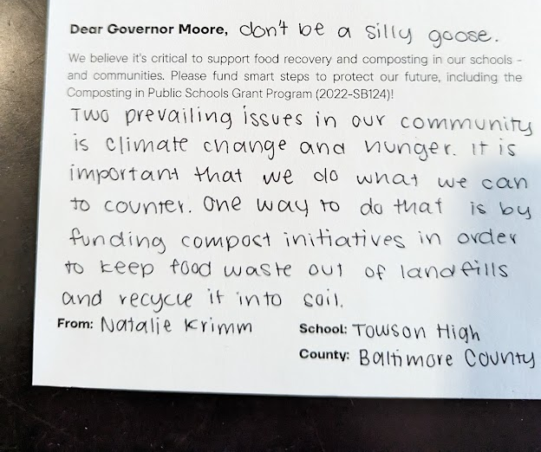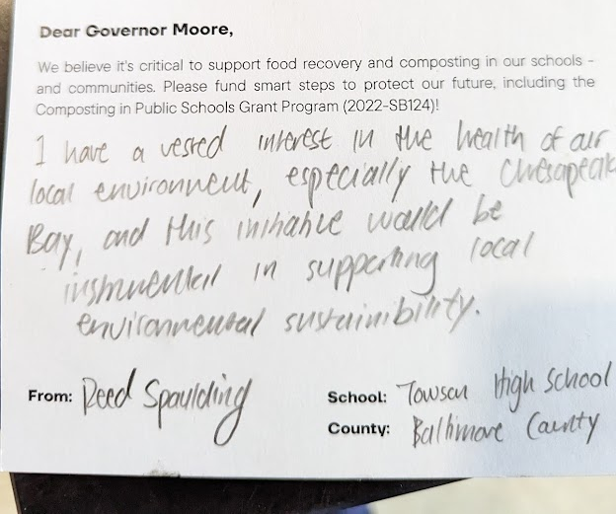
Postcards to the Governor

